Getting the compiler

<https://msdn.microsoft.com/en-us/library/ms235639.aspx?__hstc=268264337.ff2ee769db95babbdde4ab2e948c27dc.1517091241460.1517094561153.1517158370780.3&__hssc=268264337.1.1517158370780&__hsfp=1660726881>

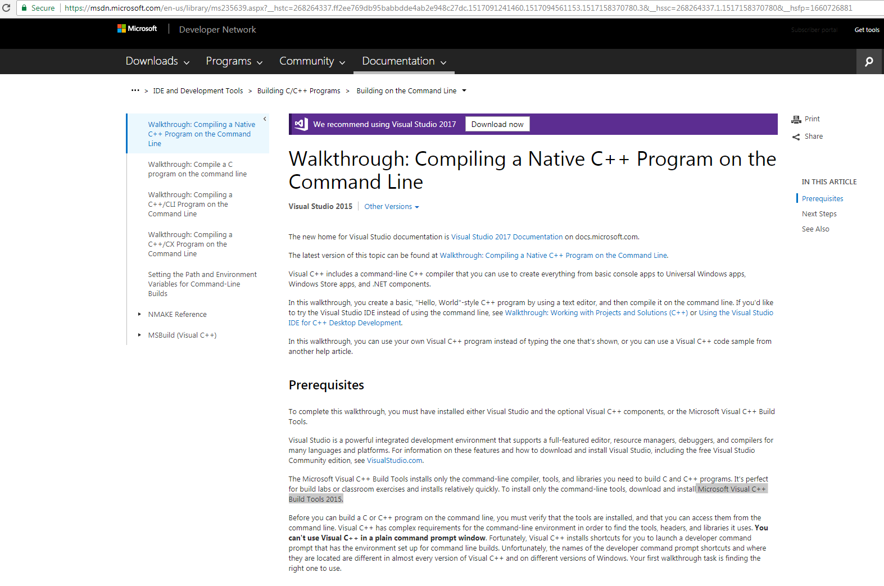

<http://go.microsoft.com/fwlink/?LinkId=691126>

Getting CMake for Windows

<https://cmake.org/download/>

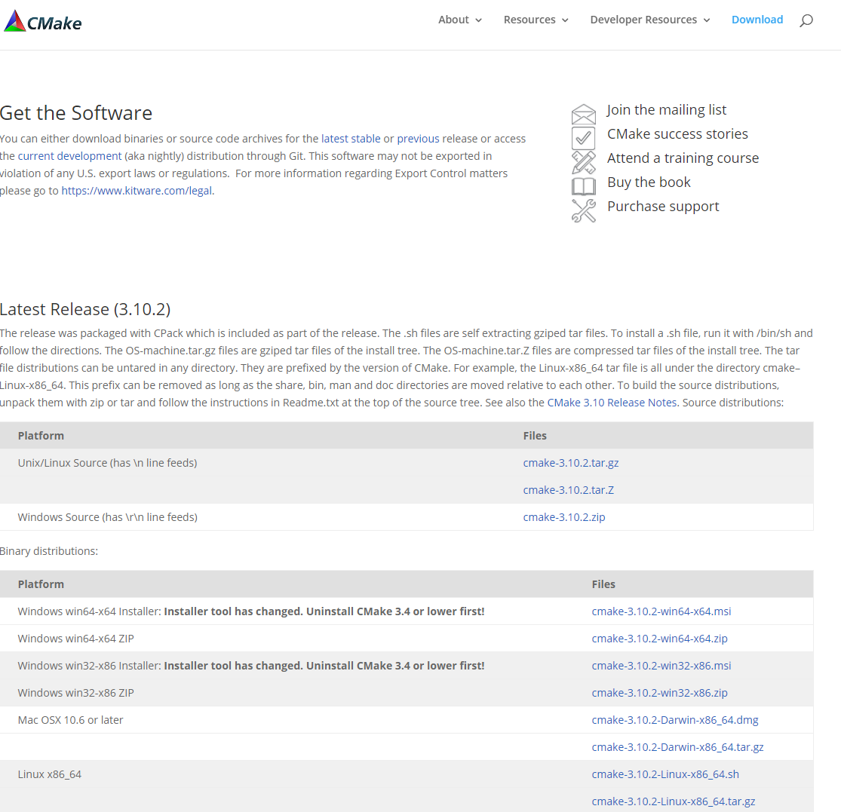

Getting OpenCV Sources

<https://opencv.org/>

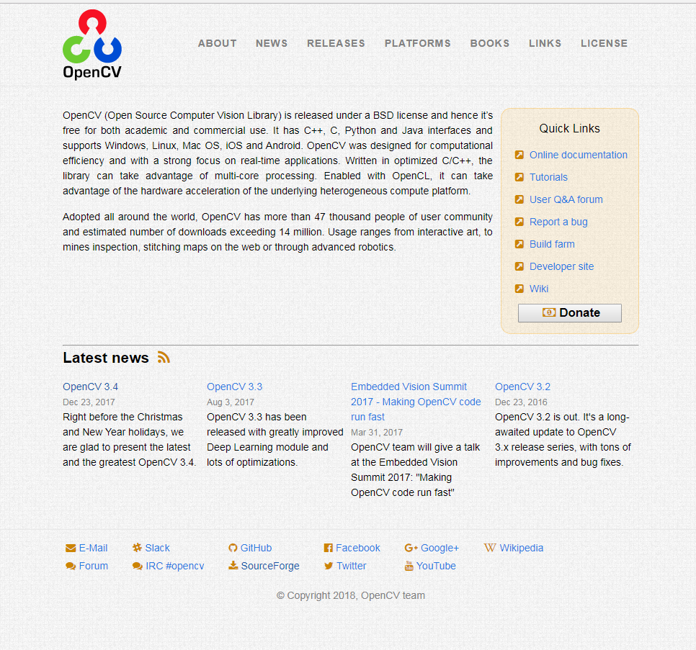

Getting Python

<https://www.python.org/downloads/>

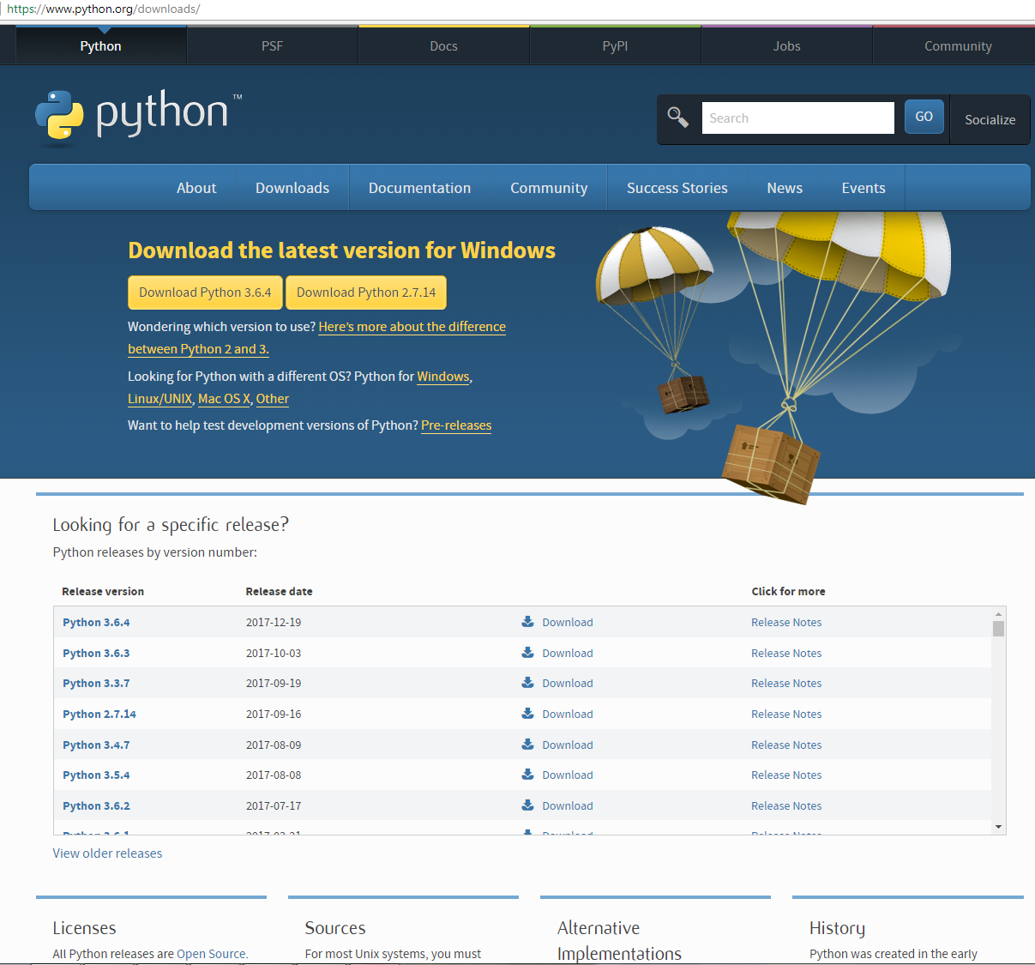

If you want to have both versions of python, you can but there are a couple of steps that you have to take. First download 2.7 and install it using the msi installer. Make the appropriate changes to your environment variables.

Download python 3.6 and do the same. Go into the python folder and rename the python.exe binary file, rename it from python 🡺 python3

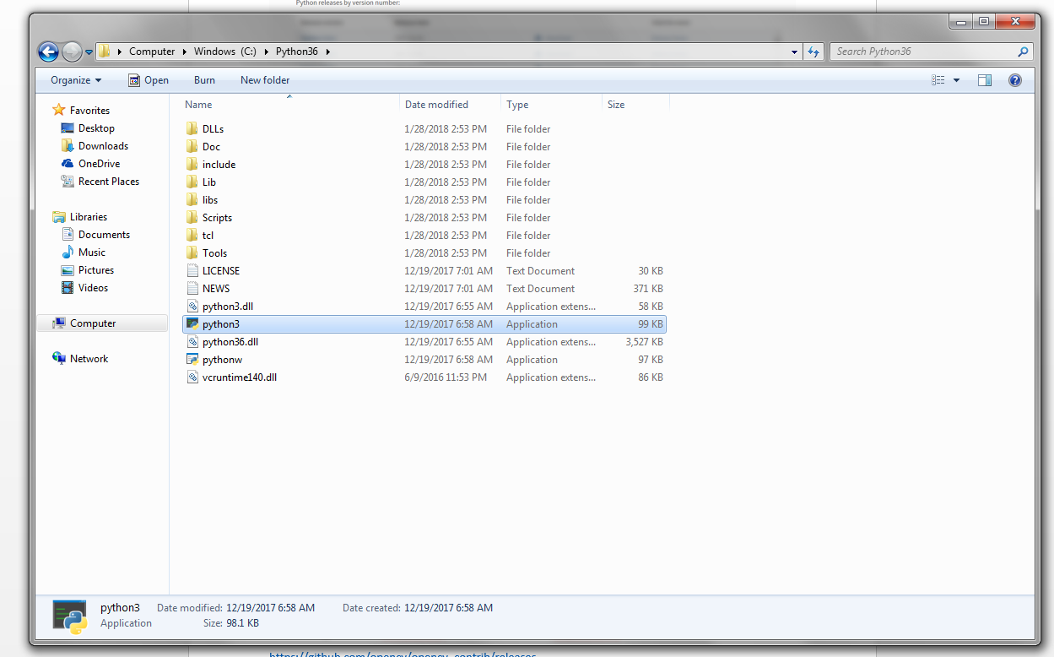

Getttng Numpy and Scipy

Go to the Unofficial Windows Binaries for Python Extension Packages Website run by Christoph Gohlke, at the Laboratory for Fluorescence Dynamics, University of California, Irvine <https://www.lfd.uci.edu/~gohlke/pythonlibs/>

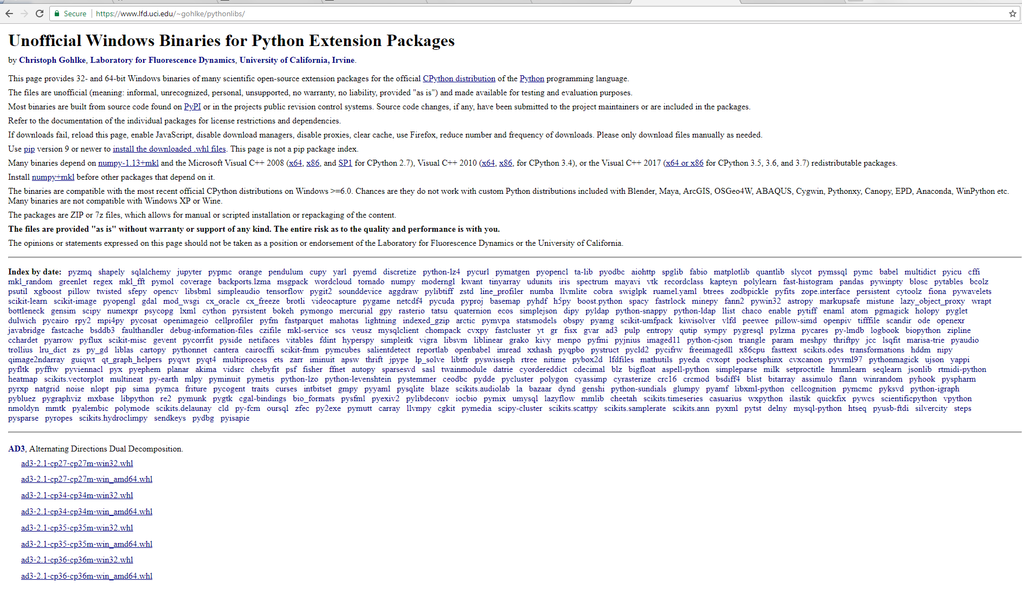

Download the wheels for numpy27, and numpy36 if you are running two versions of python, 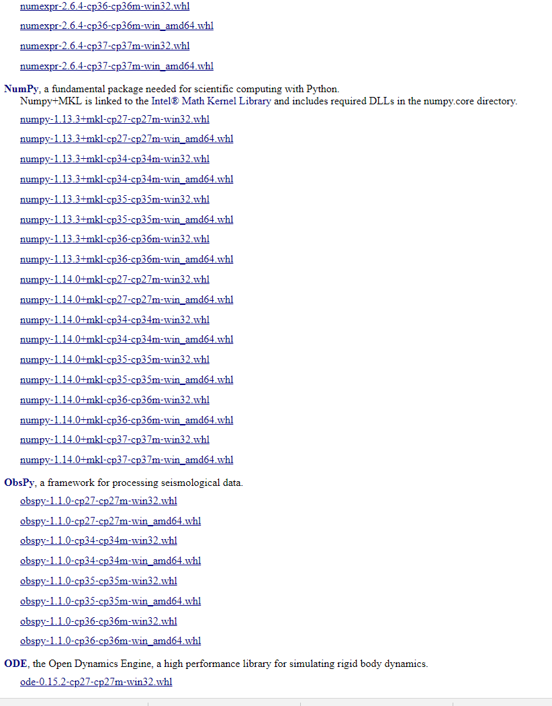

and the wheels of Scipy27, and Scipy36 for Scipy.

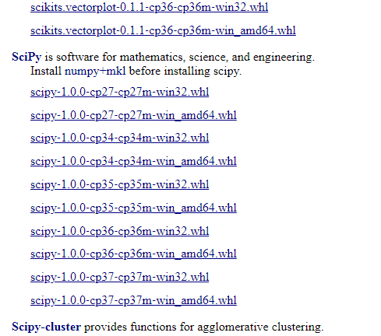

Put the cv2.py file foun in the python lib in opencv

C:\opencv\build\python\2.7\x64

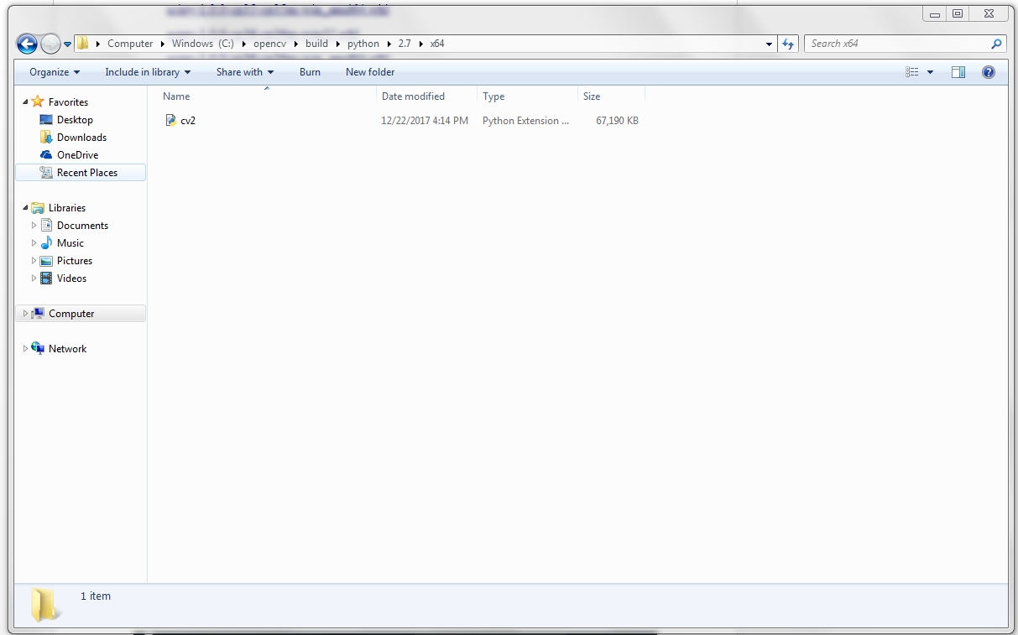

in the site-packages directory inside of python

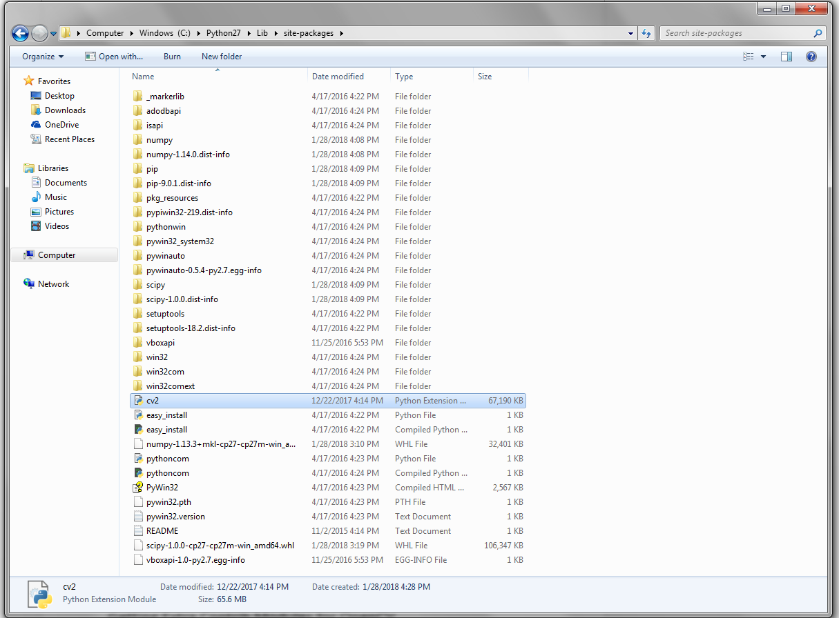

Getting Extra Contrib Modules for OpenCV

<https://github.com/opencv/opencv_contrib/releases>

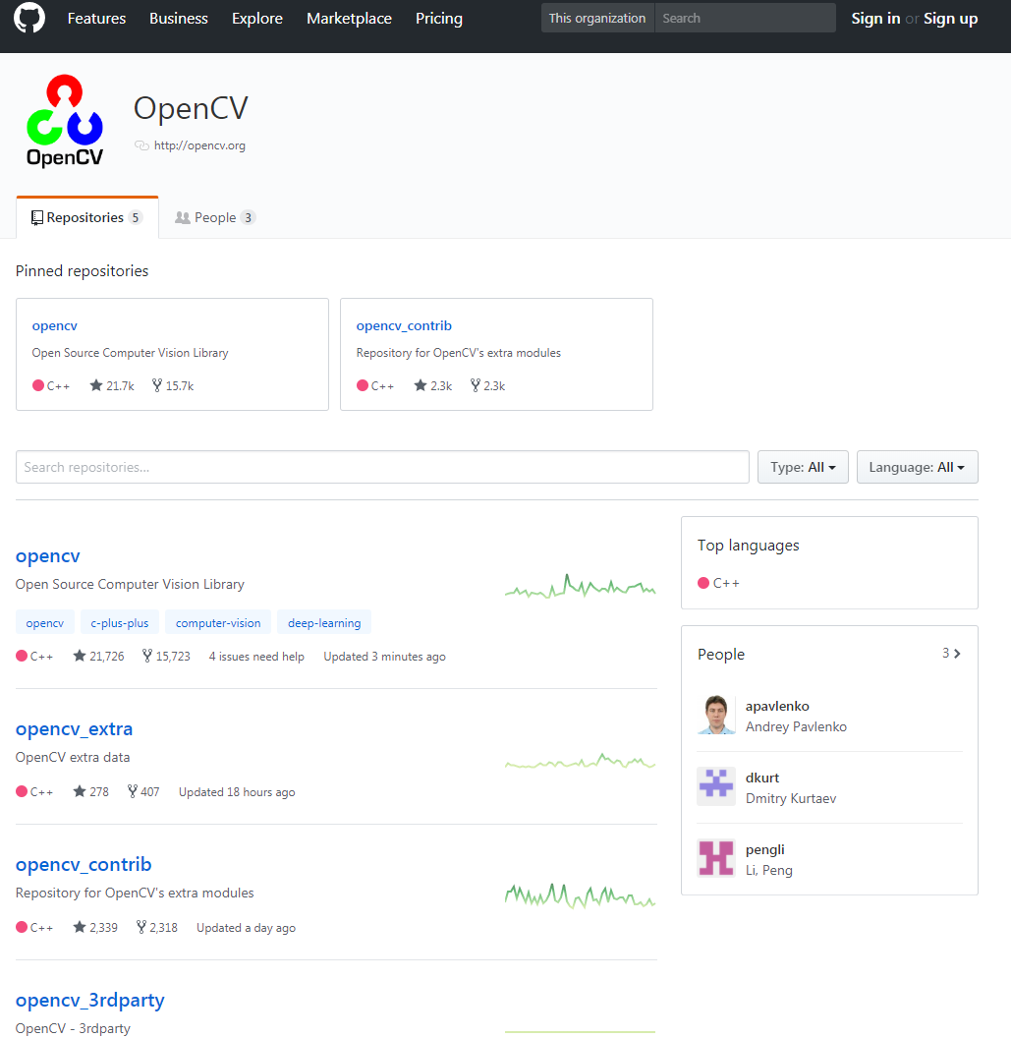

Choose the opencv_contrib link, and download the zip file.

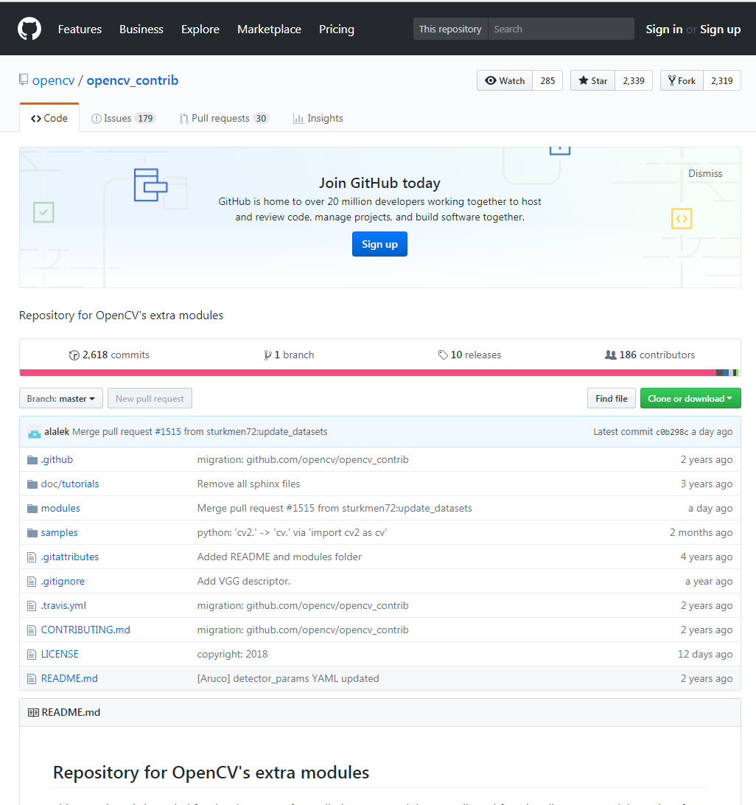

Place the opencv_contrib in the opencv directory

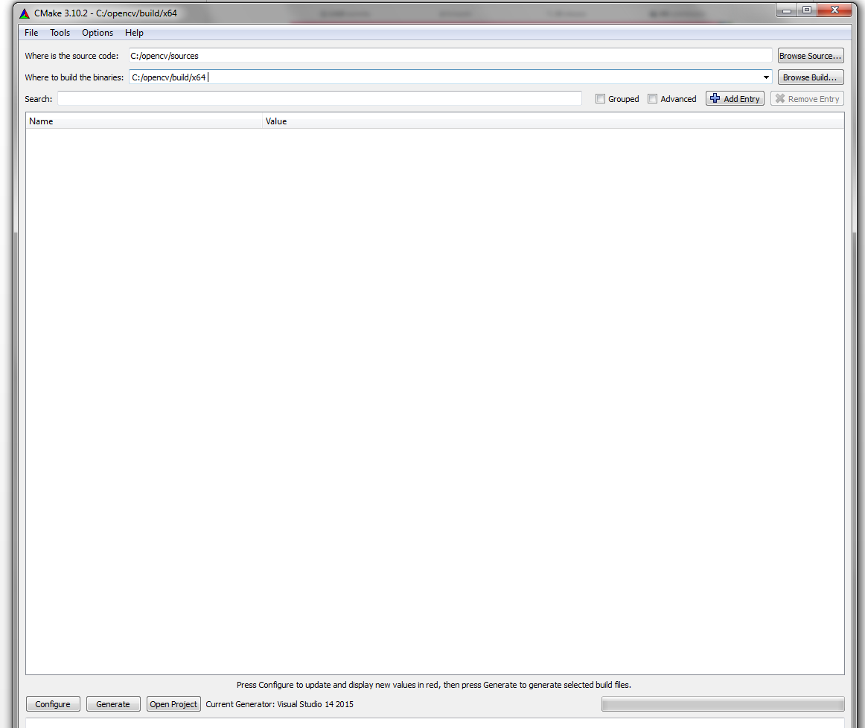

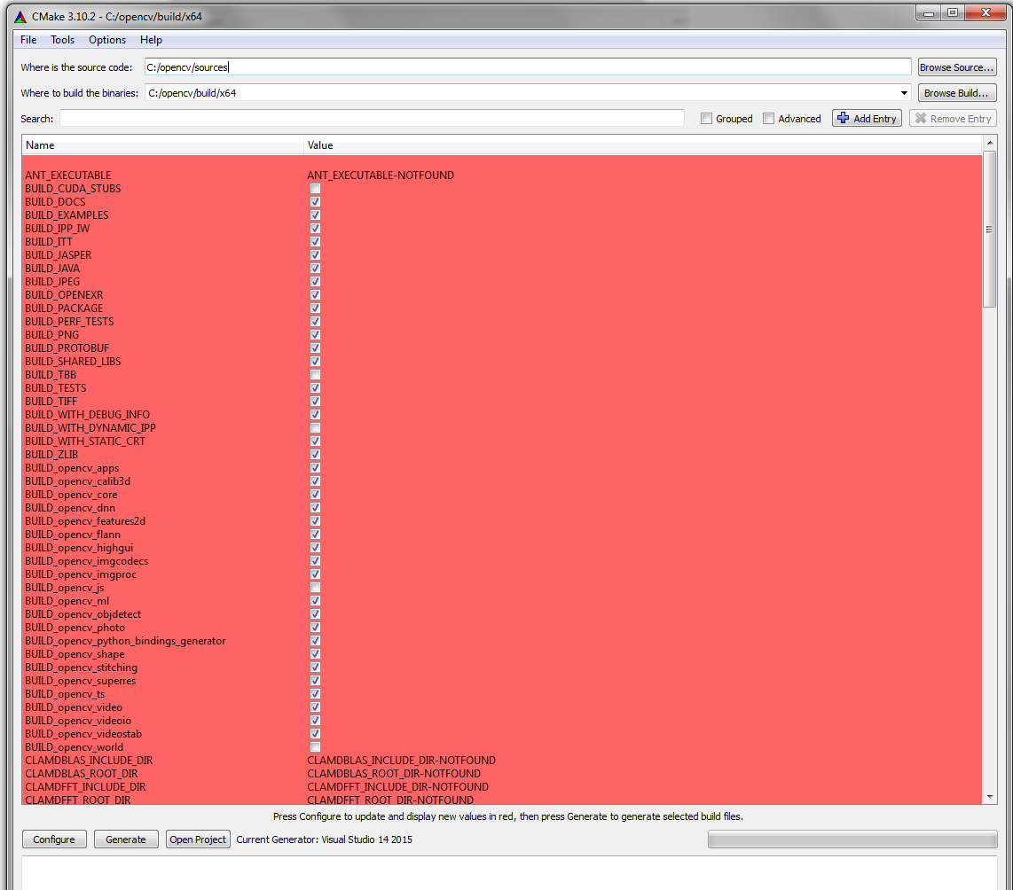

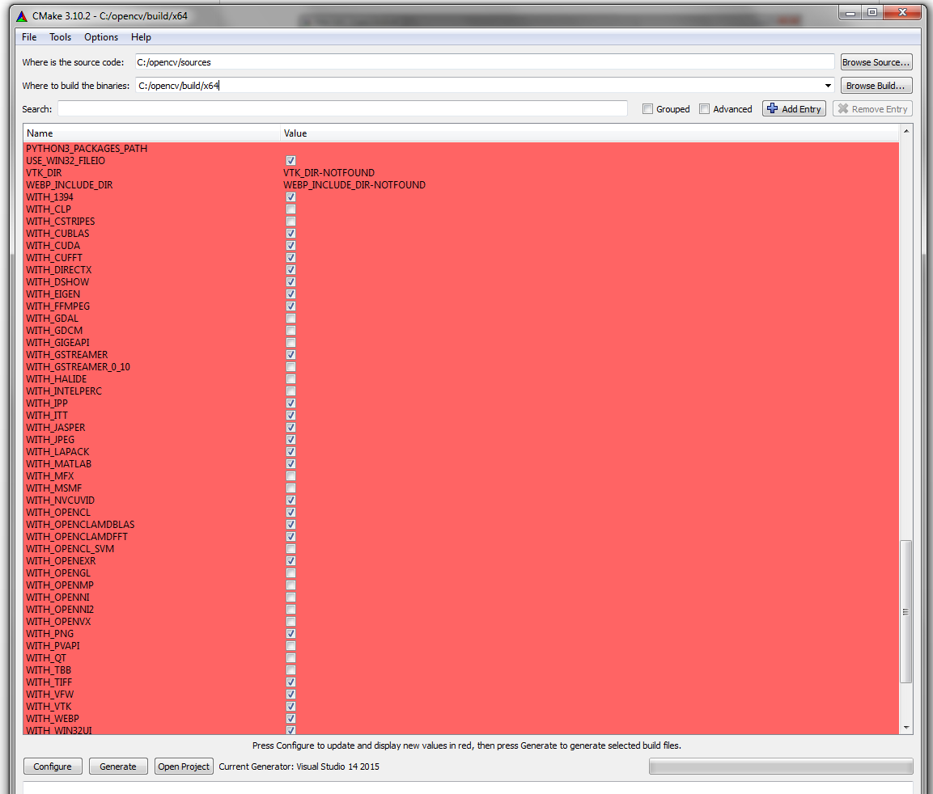

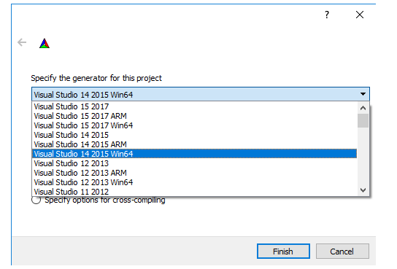

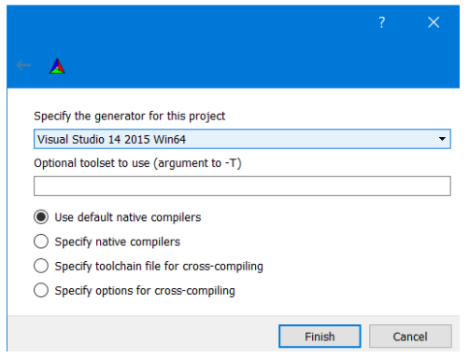

Go to wherever your build directory is, in my case is:

C:\opencv\build\x64

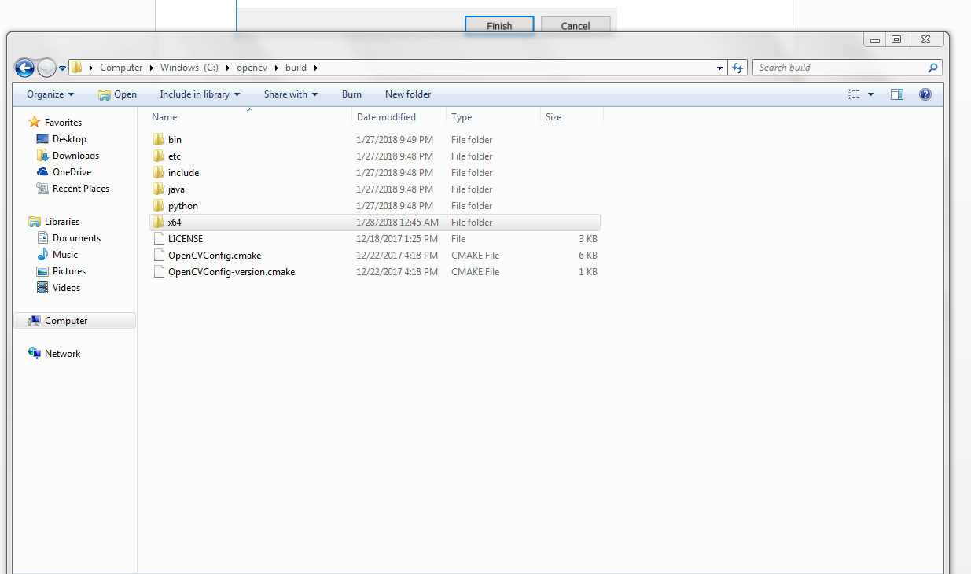

Open a command prompt that has admin rights, and enter the following command

cmake.exe --build . --config Release --target INSTALL

This will create an install directory where you can find all the binaries, header files, and linked libraries files.

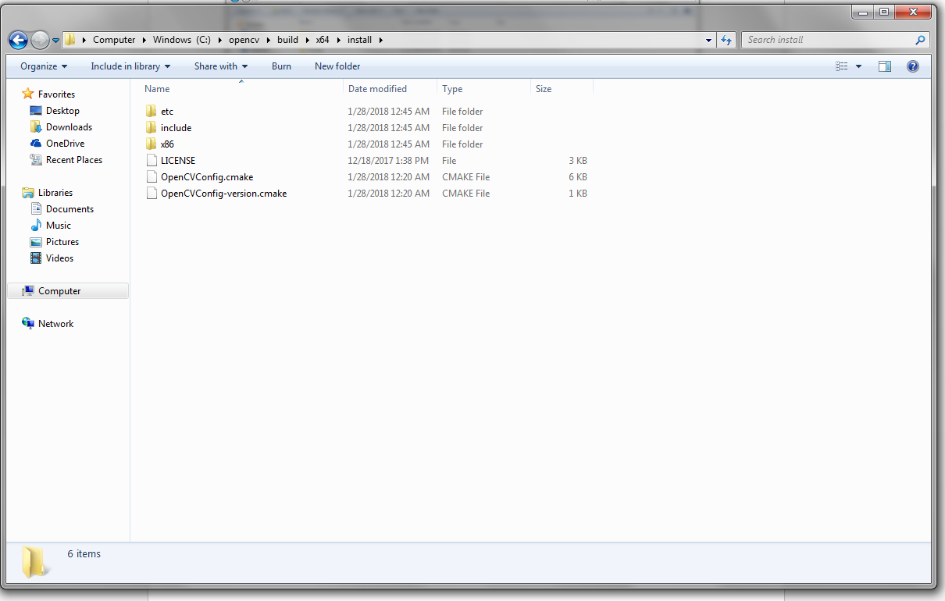

Change the paths in the environment variables

Create a CMakeLists.txt

Create a .cpp file

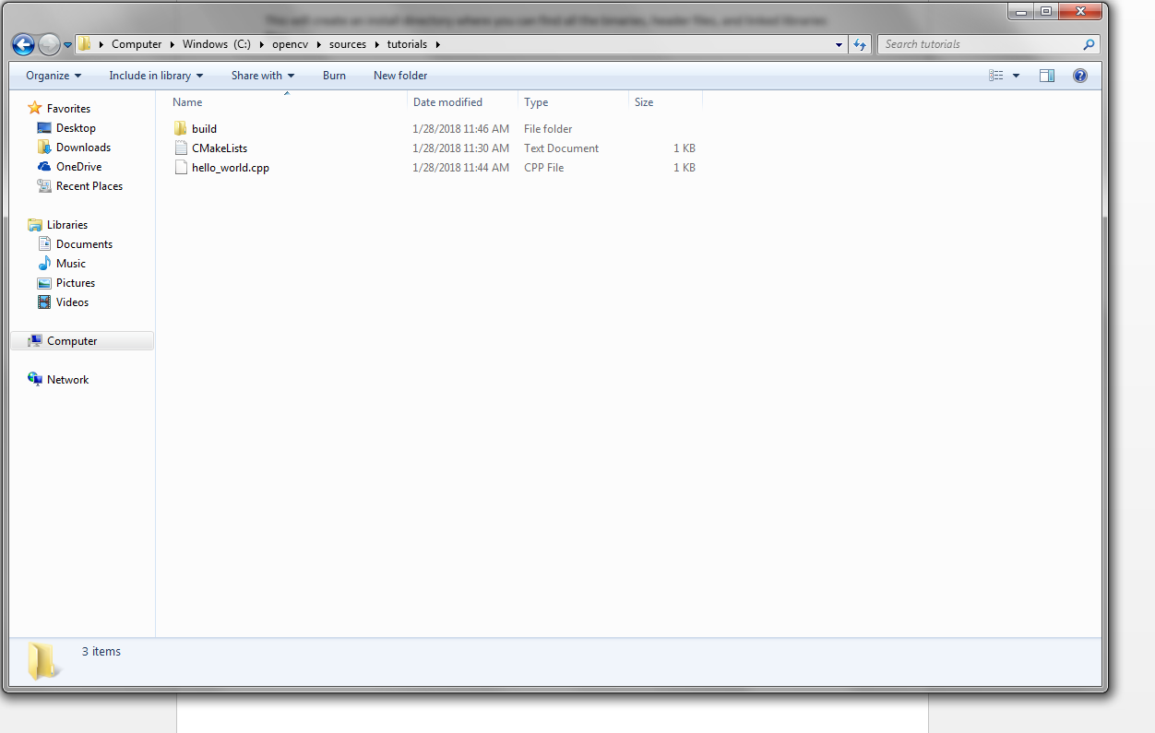

Create a build directory

cd build

cmake ..

cmake –build . –config Release

all of the build files will be in the build directory, and the executables (binaries) will be in the Release directory

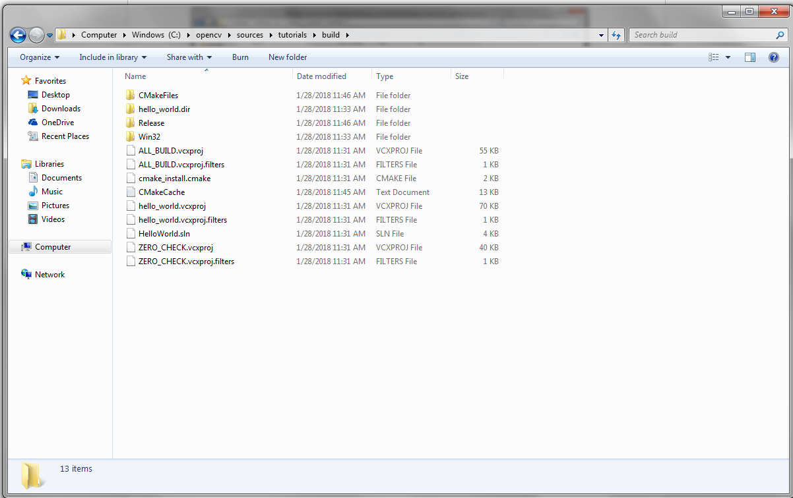

And the binaries in the Release directory

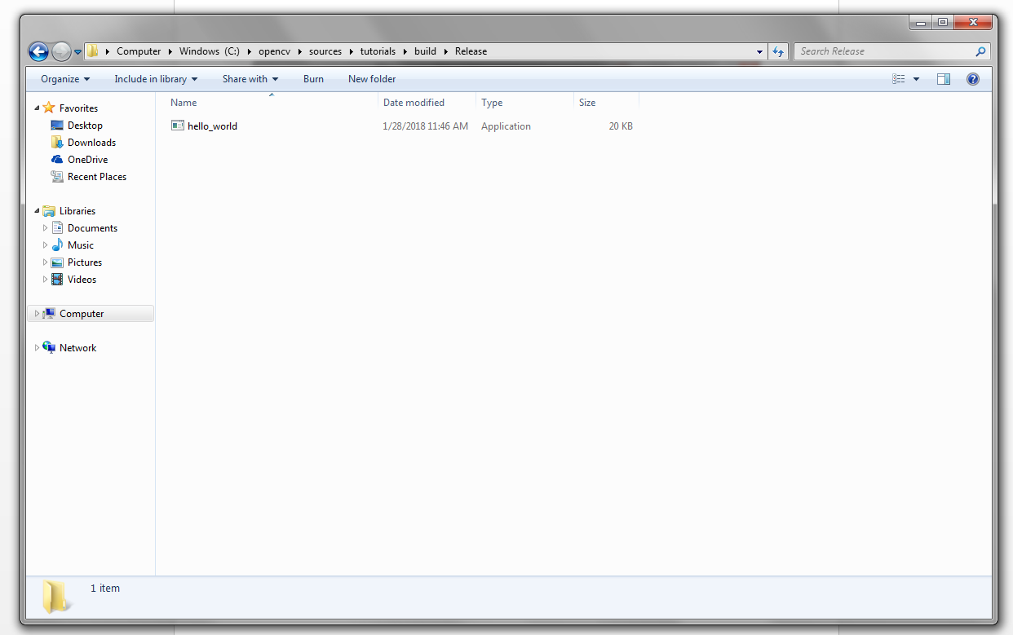

Testing Python Bindings

Python2 pip

Python2 –m pip install –upgrade pip

Python2 pip install numpy